DATE:26-02-26
EXPERIMENT - 2
Create a simple cloud software application for Flight Reservation System using any Cloud Service Provider to demonstrate SaaS.
AIM: The aim of the Flight Reservation System is to provide a cloud-based platform for users to search, book, and manage flights easily.
PROCEDURE:
STEP1:GO TO ZOHOCREATOR.COM AND LOGIN TO YOUR ACCOUNT
STEP2:CLICK CREATE NEW APPLICATION AND CREATE FROM SCRATCH
STEP3: ENTER APPLICATION NAME AND CREATE APPLICATION
STEP4:CLICK ON CREATE NEW FORM AND NAME THE FORM
STEP5:ENTER THE DETAILS
STEP6:THE SOFTWARE HAS BEEN CREATED.

STEP1:GO TO ZOHOCREATOR.COM AND LOGIN TO YOUR ACCOUNT

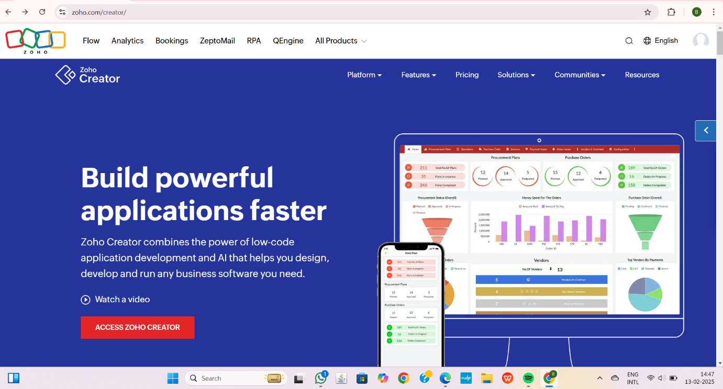

STEP2:CLICK CREATE NEW APPLICATION AND CREATE FROM SCRATCH
STEP3: ENTER APPLICATION NAME AND CREATE APPLICATION

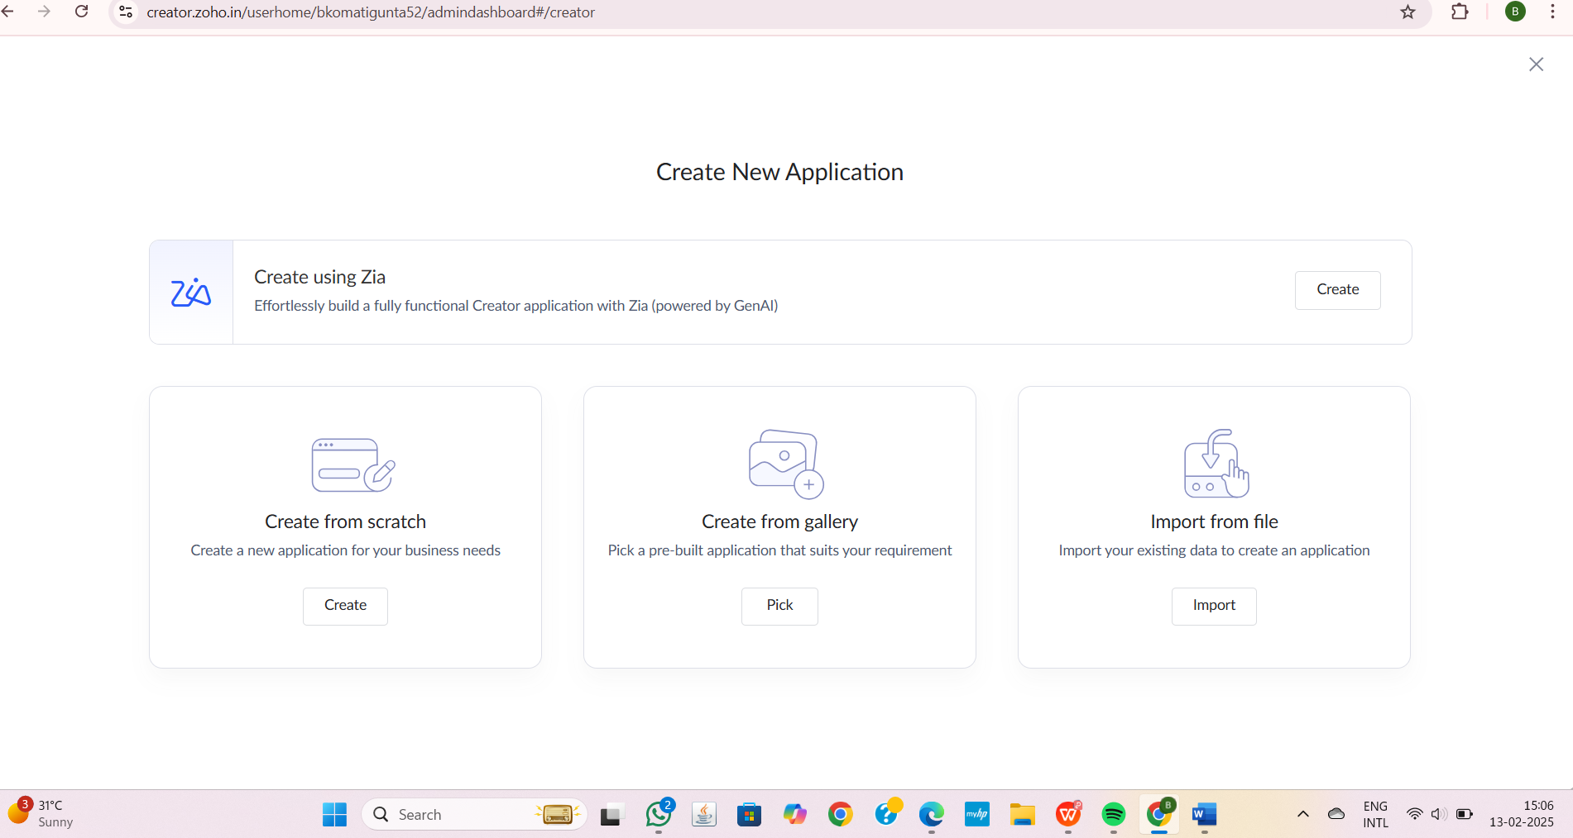

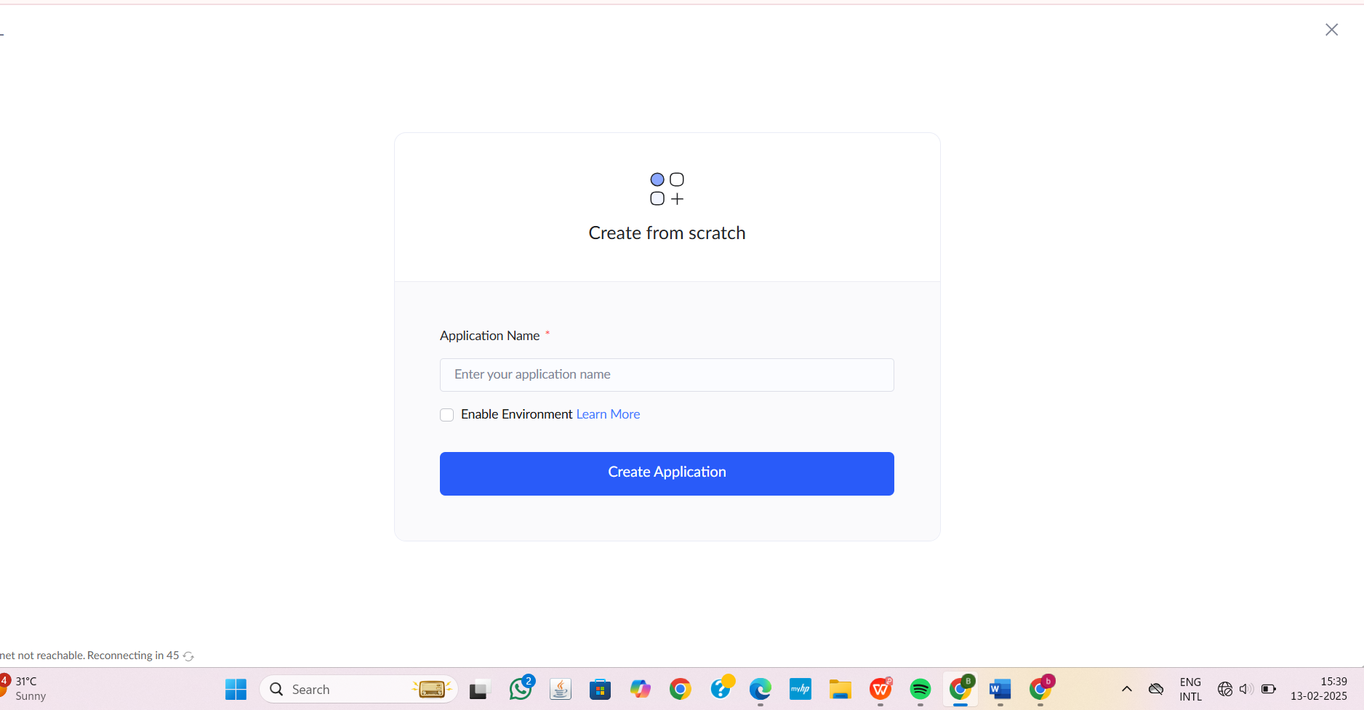

STEP4:CLICK ON CREATE NEW FORM AND NAME THE FORM

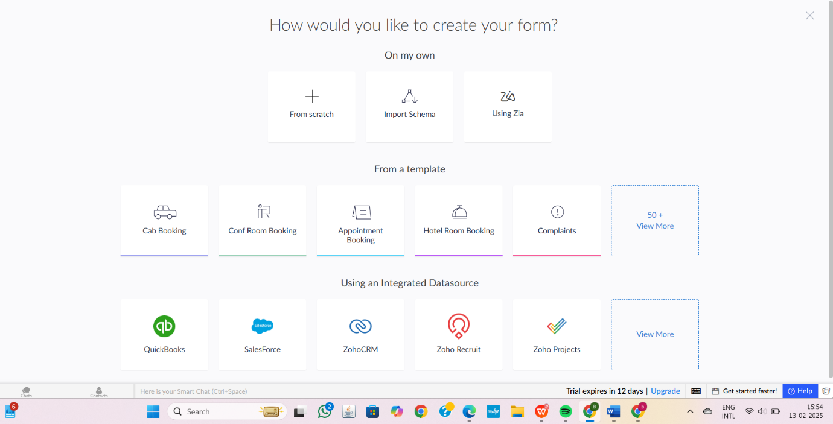

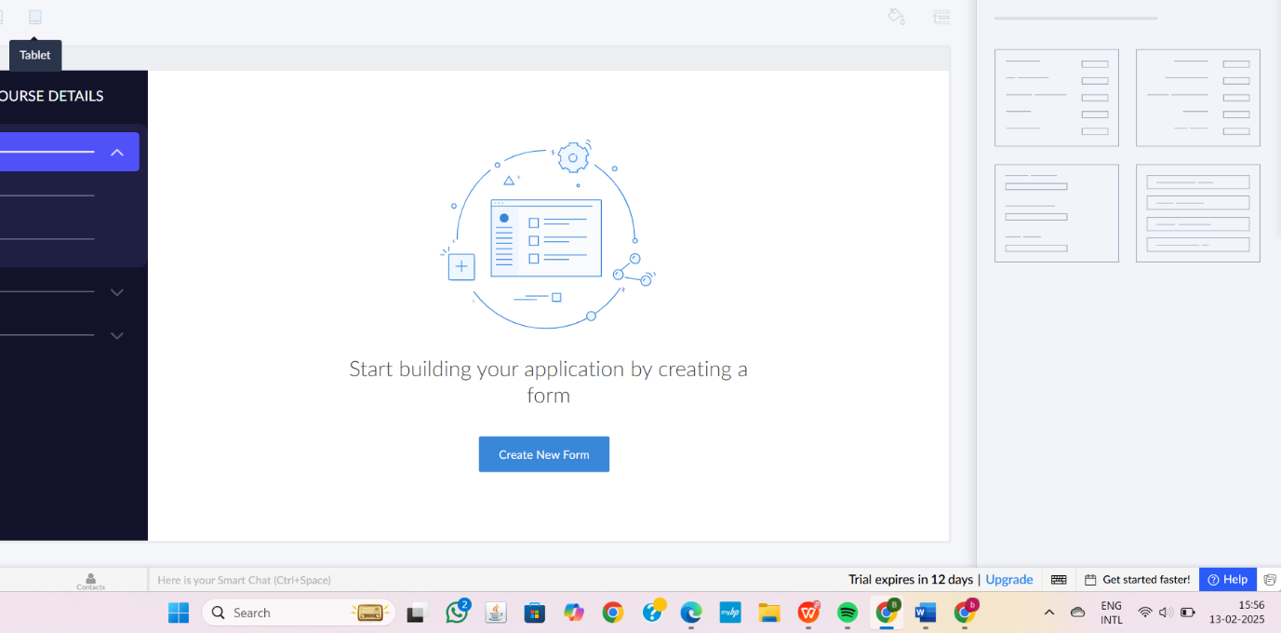

1.FLIGHT INFORMATION AND ITS DETAILS

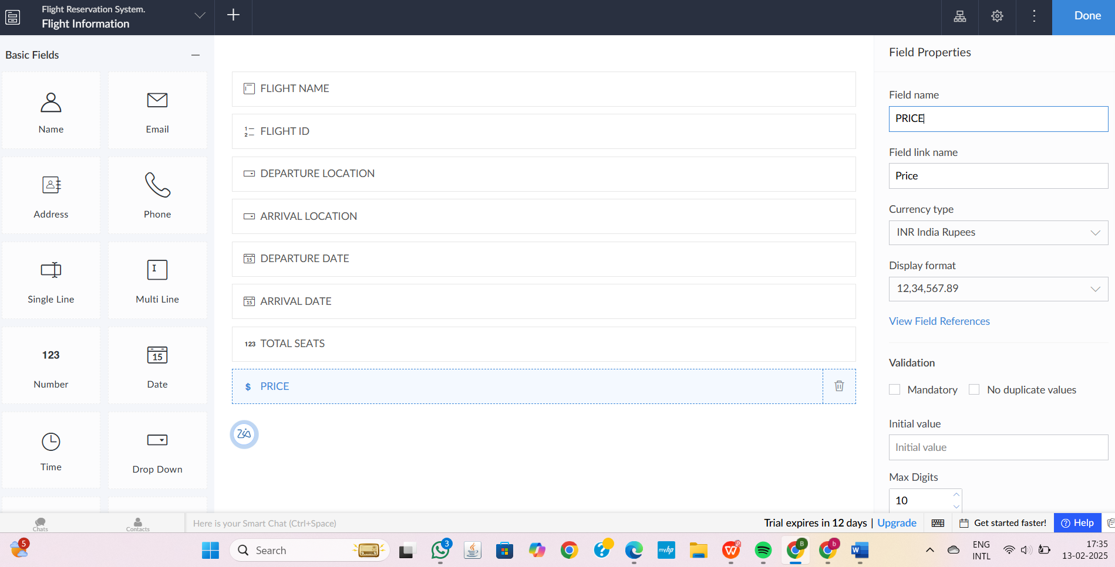
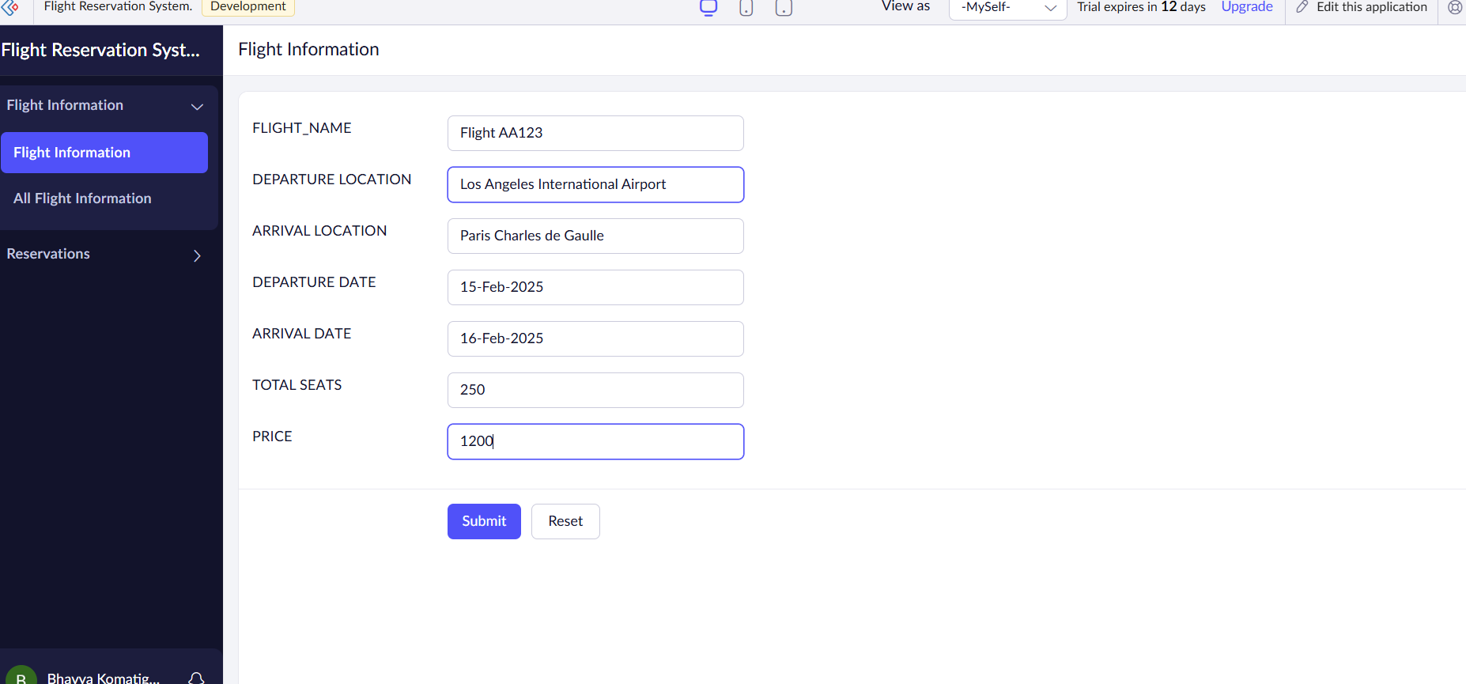
2.RESERVATION DETAILS
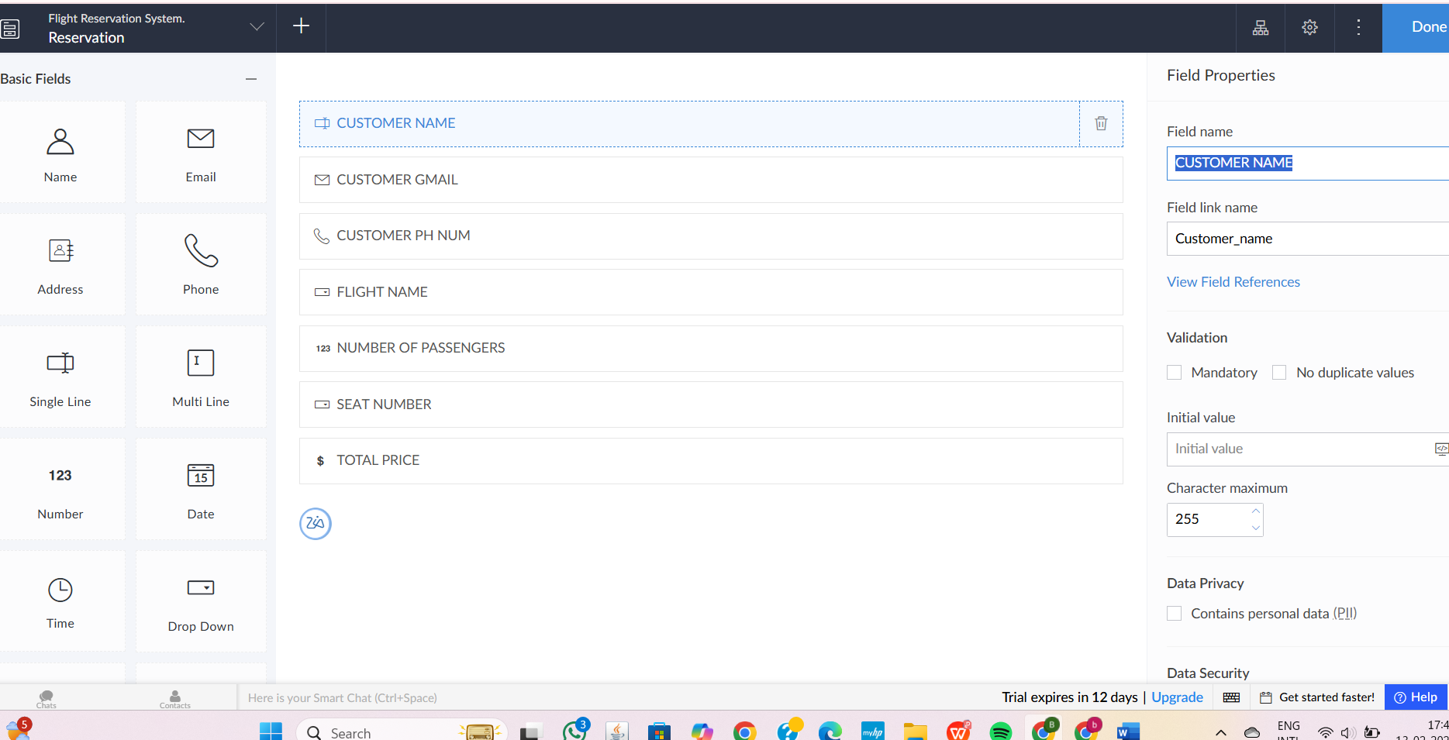

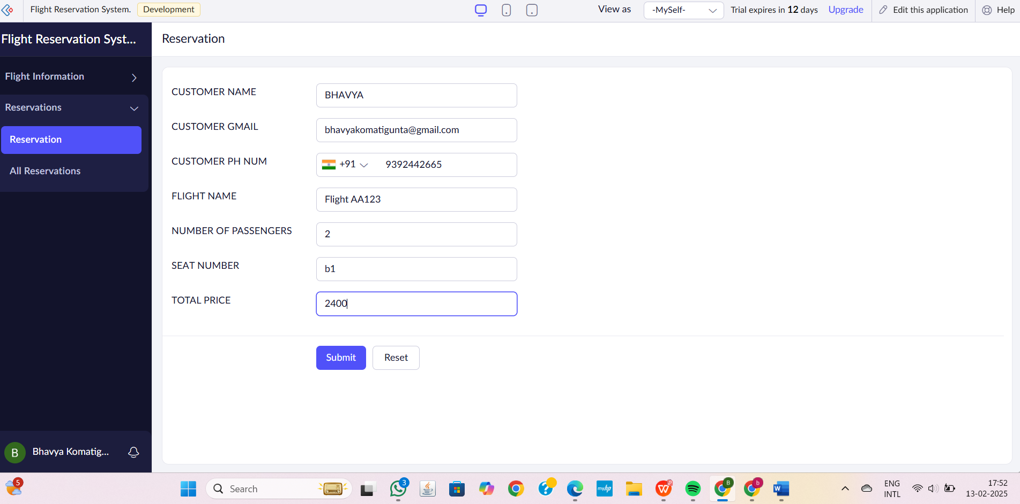

3.PAYMENT DETAILS

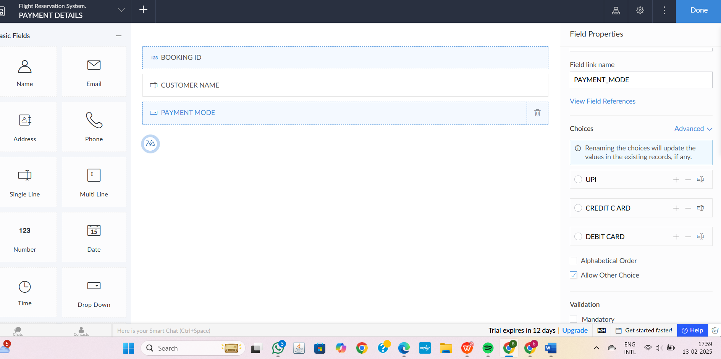

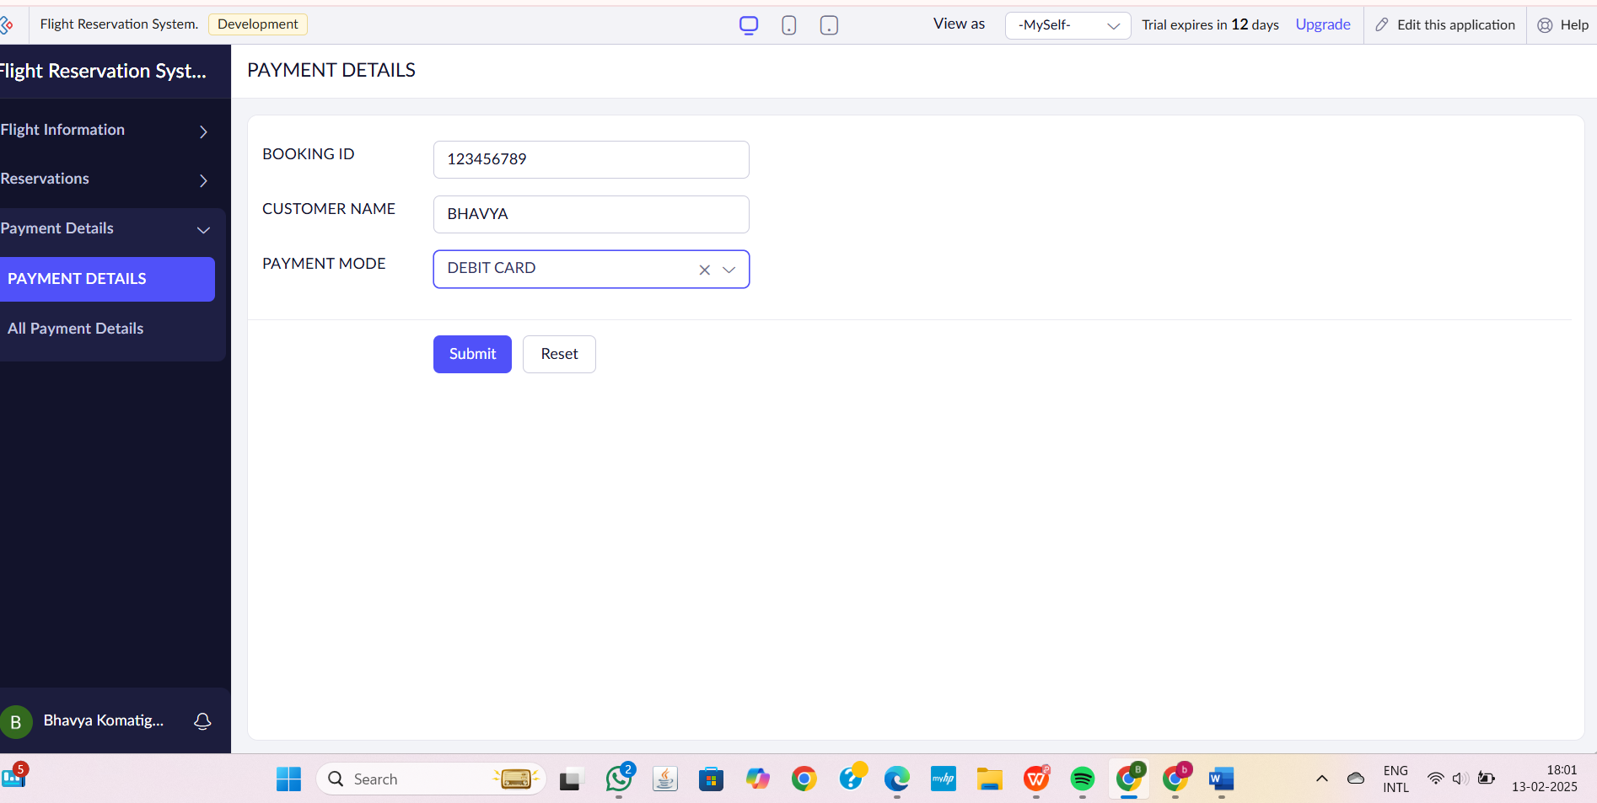

STEP6:THE SOFTWARE HAS BEEN CREATED.

